Tumour-core, peritumoral-margin and remote-context evidence in brain MRI classification: a sham-controlled counterfactual audit with descriptive plane stratification across CNN and Vision Transformer models
Chhotu^{1*} and Rishi Gupta²
¹Manipal University Jaipur, Jaipur, Rajasthan, India.
²Department of Computer Science and Engineering, School of Computer Science and Engineering, Faculty of Science, Technology and Education, Manipal University Jaipur, Jaipur, Rajasthan, India.
*Corresponding author(s). E-mail(s): chhotu.2427030521@muj.manipal.edu;
Contributing authors: rishi.gupta@jaipur.manipal.edu;
Abstract
Deep convolutional neural networks (CNNs) and Vision Transformers (ViTs) can achieve high benchmark performance on brain MRI classification, but performance on unmodified images does not establish which anatomical regions support a prediction. Tumour-core morphology, adjacent peritumoral tissue, remote parenchyma and generic image-perturbation effects should be distinguished before model behaviour is interpreted as clinically meaningful evidence. We conducted a sham-controlled, region-resolved counterfactual audit on two contrast-enhanced MRI cohorts: the Cheng dataset (3,064 slices from 233 patients; three tumour classes) and the multi-plane BRISC dataset (6,000 slices; glioma, meningioma, pituitary tumour and no-tumour classes). Cheng partitions were generated with patient-grouped five-fold stratification; the exported baseline prediction file represents the held-out Fold 1 partition (480 slices from 49 patients), not pooled predictions from all five folds. ResNet-50 and DeiT-Small/16 were fine-tuned from ImageNet-pretrained weights. For each eligible tumour-containing slice we defined the tumour core, a 4-pixel immediate margin, a 12-pixel outer margin, remote tissue and a contralateral sham region, and perturbed each region with Telea inpainting and locally matched Gaussian texture filling. The counterfactual evaluation comprised 90 slices (45 per dataset), two architectures, five regions and two perturbation methods (1,800 prediction observations). Effects were summarised as raw changes in ground-truth-class probability and sham-corrected sensitivity, using paired Wilcoxon tests, Holm adjustment, patient/case-clustered analyses and paired effect sizes. A decoded-pixel duplicate audit was also performed on the locally evaluated BRISC archive. On the Cheng Fold 1 partition, DeiT-Small achieved accuracy 0.8458, macro-F1 0.8403 and 10-bin expected calibration error (ECE) 0.0366; ResNet-50 achieved 0.7583, 0.7190 and 0.1835. On the BRISC clean 899-image test set, DeiT-Small achieved accuracy 0.8265 and macro-F1 0.8344, against 0.6963 and 0.6991 for ResNet-50. For DeiT-Small on Cheng, Telea removal of the tumour core yielded a mean sham-corrected sensitivity of 0.1282 (slice-level Wilcoxon p = 9.13×10⁻⁶; Holm-adjusted p = 3.65×10⁻⁵; patient-clustered Wilcoxon p = 0.0059); the corresponding ResNet-50 value was 0.0311. On BRISC, DeiT-Small core sensitivity was 0.0517 (raw p = 1.85×10⁻⁶; Holm-adjusted p = 7.40×10⁻⁶), while immediate-margin and outer-margin effects were 0.0239 (Holm-adjusted p = 0.0188) and 0.0301 (Holm-adjusted p = 0.0147). In the pooled comparison, DeiT-Small showed greater core sensitivity than ResNet-50 (difference 0.0738; slice-level p = 0.0123; Holm-adjusted p = 0.0980; cluster-level Wilcoxon p = 0.0162). Remote-region effects were not statistically distinguishable from sham in the highlighted comparisons. In the evaluated BRISC archive, 159 exact decoded-pixel duplicate pairs were found, and 101 of 1,000 test images had exact matches across the train/test boundary; this archive-specific observation was handled by reporting both official and de-duplicated partitions, with the clean subset serving as a sensitivity check. Tumour-core and selected peritumoral regions contribute to model predictions, but effect size and statistical support depend on cohort, architecture, region and perturbation method. Remote edits generally showed smaller effects than lesion-centred edits, but the study does not establish complete invariance to all background shortcuts. These experiments are a retrospective mechanistic audit of spatial reliance in single-run baseline models, not clinical validation or evidence of diagnostic deployability.
Keywords: brain tumour MRI, counterfactual intervention, peritumoral margin, shortcut learning, ResNet-50, DeiT-Small, Vision Transformer, data leakage, calibration
1 Introduction
Automated classification of primary intracranial neoplasms from contrast-enhanced magnetic resonance imaging (CE-MRI) is a foundational task in computer-aided neuro-oncology. Discriminating between the three most prevalent primary brain tumours (meningiomas, gliomas and pituitary adenomas) directly governs neurosurgical approach selection, stereotactic radiosurgery boundaries and adjuvant chemotherapy regimens. Over the past decade, deep learning systems based on convolutional neural networks (CNNs) and Vision Transformers (ViTs) have repeatedly reported benchmark classification accuracies exceeding 90% to 95% on public MRI datasets [2, 5].
Despite these nominal scores, translational deployment of medical imaging AI into clinical radiology workflows remains impeded by vulnerability to shortcut learning and the “Clever Hans” effect [1, 11]. Wallis and Buvat [1] showed that deep classifiers trained on a widely used public brain tumour MRI dataset achieved high diagnostic accuracy even when the entire intracranial brain compartment was occluded. The models were inadvertently exploiting acquisition-site background noise, skull thickness signatures and scanner artefacts rather than pathological tissue. Furthermore, unaddressed patient-level data leakage and slice-to-slice correlation across cross-validation splits distort reported metrics and create a false impression of clinical generalisation [6]. Interpretability claims for high-stakes imaging models also need to be tested rather than assumed [13].
Existing methodologies for auditing spatial reliance suffer from two main limitations:
- Coarse binary masking and out-of-distribution shift. Prior occlusion studies predominantly replace entire cerebral hemispheres or rectangular tiles with zero-intensity black patches or uniform noise [3, 4]. This introduces sharp, high-frequency boundary cliffs and out-of-distribution (OOD) domain shift, making it impossible to determine whether a performance collapse is caused by the loss of diagnostic evidence or by network failure on unnatural artefacts.
- Absence of anatomically matched controls. Standard ablation studies lack matched sham controls. Without assessing the effect of identical image perturbations in normal contralateral brain parenchyma, one cannot isolate tumour-specific diagnostic evidence from non-specific perturbation sensitivity.
Research objectives and hypotheses. To address these challenges, we design and execute a literature-informed, sham-controlled counterfactual audit with descriptive plane stratification across CNN (ResNet-50) and Vision Transformer (DeiT-Small/16) architectures (Fig. 1). The study is a mechanistic audit of spatial reasoning in two research-grade classifiers; it is not a diagnostic tool and makes no claim of clinical deployability. We investigate five hypotheses:
- Hypothesis 1 (spatial evidence gradient). Lesion-centred perturbations are expected to produce larger sham-corrected changes than remote-region perturbations; the magnitude and ordering may vary by cohort, model and perturbation operator.
- Hypothesis 2 (transitional margin contribution). The immediate 4-pixel margin may contribute predictive evidence beyond the matched sham response; this is tested separately by cohort and with multiplicity correction.
- Hypothesis 3 (architectural inductive bias). ResNet-50 and DeiT-Small may exhibit different regional sensitivity and calibration profiles; the direction and robustness of any difference are empirical questions.
- Hypothesis 4 (perturbation method concordance). Regional sensitivity estimates may be concordant across Telea inpainting and locally matched texture filling; this is evaluated rather than assumed.
- Hypothesis 5 (benchmark leakage and prior distortion). The locally evaluated BRISC archive may contain exact duplicate matches across partitions; any finding is specific to the inspected archive and is not presumed to apply to every distribution.
2 Related work
2.1 Shortcut learning in medical image analysis
Shortcut learning occurs when machine learning models achieve high nominal accuracy by exploiting spurious decision rules that fail under distributional shift [11]. In radiographic COVID-19 detection, DeGrave et al. [14] demonstrated that deep networks relied heavily on hospital-specific radiopaque markers and scanner-bed textures rather than pulmonary consolidations. In neuro-oncology, Wallis and Buvat [1] showed that skull and background features alone supported high classification accuracy, so benchmark performance on public MRI datasets cannot be accepted without region-resolved attribution audits.
2.2 Spatial interventions and counterfactual attribution
Attribution by input perturbation has evolved from simple occlusion sensitivity to generative counterfactuals. Goyal et al. [12] formalised counterfactual visual explanations by identifying minimal edits required to alter class predictions. Rossi et al. [3] introduced TACE (Tumour-Aware Counterfactual Explanations) as a preprint framework to evaluate classifier behaviour under generative lesion insertion and removal. Sourget et al. [4] investigated model sensitivity to unexpected anatomical regions in radiographic images. Among the studies we reviewed, prior medical imaging intervention studies evaluated CNNs rather than Vision Transformers and did not use matched contralateral controls to cancel generic inpainting artefacts.
2.3 Brain-tumour MRI classification and benchmark leakage audits
The brain tumour dataset published by Cheng et al. [2] (N = 3,064 slices) has served as a foundational benchmark for over a decade. Recently, Fateh et al. [5] introduced the BRISC benchmark (N = 6,000 multi-plane slices). Public medical datasets frequently suffer from duplicate contamination and patient split leakage. As demonstrated by Yagis et al. [6], random slice-level cross-validation without patient grouping results in near-perfect slice memorisation and inflated performance estimates.
3 Datasets, provenance and data leakage audit
3.1 Datasets and cohort overview
We evaluated two contrast-enhanced T1-weighted brain MRI datasets:
- The Cheng dataset [2]. 3,064 CE-T1 slices from 233 unique patients across three tumour classes: 708 meningiomas, 1,426 gliomas and 930 pituitary adenomas. Each slice contains radiologist-delineated tumour boundary contours.
- The BRISC dataset [5]. 6,000 skull-stripped CE-MRI slices partitioned into an official training set (N = 5,000, split into 4,000 train and 1,000 validation) and an official test set (N = 1,000) across four classes (glioma, meningioma, pituitary tumour and no-tumour controls), imaged in axial, coronal and sagittal planes. Usable segmentation masks are available for 860 test neoplasm slices.
3.2 Sample accounting and selection rules
To ensure transparency and reproducibility across all reported tables and figures, the sample flow and selection rules are as follows (Fig. 1).
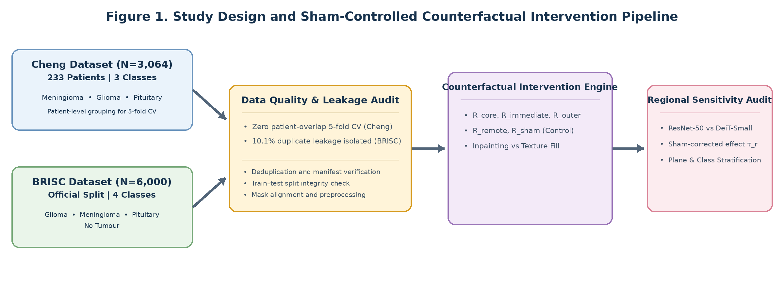
Fig. 1 Study design and sham-controlled counterfactual intervention pipeline: (A) ingestion and provenance audit of the Cheng (N = 3,064) and BRISC (N = 6,000) cohorts; (B) five-region topological decomposition; (C) dual perturbation engines; (D) paired model evaluation across ResNet-50 and DeiT-Small.
- Baseline evaluation partitions.
  - For Cheng (N = 3,064 slices across 233 patients), a five-fold patient-isolated cross-validation split was created. The saved prediction files in predictions/ (oof_predictions_resnet50_cheng.csv and oof_predictions_deit_small_patch16_224_cheng.csv) contain exactly N = 480 records, all belonging to Fold 1 (evaluated on 49 unseen patients). Slices from folds 2–5 are not included in these exported prediction logs; this partition is therefore designated the patient-isolated held-out Fold 1 test partition (N = 480) rather than an aggregated all-fold out-of-fold set.
  - For BRISC, the complete official test predictions (N = 1,000) are exported in predictions/test_predictions_resnet50_brisc.csv and predictions/test_predictions_deit_small_patch16_224_brisc.csv, while the clean de-duplicated predictions (N = 899) are exported in the corresponding *_brisc_clean.csv files. The mask-supported neoplasm evaluation subset (N = 480; 254 gliomas, 226 meningiomas) is preserved in predictions/test_predictions_*_neoplasm_480.csv.
- Counterfactual intervention QC manifest (N = 1,200). Phase 6 candidate pool, recorded in manifests/intervention_qc.csv across 120 unique slices (60 Cheng, 60 BRISC), five regions (R_{core}, R_{immediate}, R_{outer}, R_{remote}, R_{sham}) and two perturbation engines (Method A: Telea inpainting; Method B: Gaussian texture fill), giving 120 × 5 × 2 = 1,200 verified records. All 90 evaluated slices (45 Cheng + 45 BRISC) have complete, verified QC records in this manifest, confirming zero non-target corruption (|Δ| < 10⁻⁵). The remaining 30 candidate slices were not part of the balanced evaluation protocol below, which retains 15 slices per tumour class in Cheng and 15 per acquisition plane in BRISC.
- Paired counterfactual observations (N = 1,800). Phase 7 balanced evaluation protocol, evaluated across 45 matched slices per dataset (N = 90 in total), five regions, two perturbation methods and two architectures (ResNet-50 and DeiT-Small); the 90 slices × 20 conditions yield 1,800 paired predictions. In Cheng, the 45 slices comprise 15 gliomas, 15 meningiomas and 15 pituitary adenomas, and originate from N = 10 unique patient clusters (3 to 7 slices per patient). In BRISC, the 45 slices comprise 15 axial, 15 coronal and 15 sagittal slices (15 per acquisition plane) across the three neoplasm classes. The total of 90 slices × 5 regions × 2 methods × 2 architectures = 1,800 rows is stored in predictions/intervention_effects.csv.
3.3 Duplicate audit and split policy
- Cheng patient-isolated five-fold cross-validation. Embedded MATLAB struct headers were parsed to extract patient identifiers (PID). A five-fold split was established using StratifiedGroupKFold (n_splits = 5, shuffle = True, random_state = 42) on patient ID. Automated set intersection verified zero patient overlap across folds (intersection = ∅).
- BRISC duplicate discovery and provenance. In the Kaggle development distribution of BRISC used here (manifests/duplicate_pairs.csv), perceptual hashing (pHash, dHash, aHash) and decoded SHA-256 pixel-matrix verification identified 159 exact duplicate image pairs (identical decoded SHA-256 pixel matrices). Of these, 110 pairs cross the official train–test split boundary, involving 101 unique test slices (10.1% of the 1,000-slice test set) that are identical copies of training/validation images (96 meningiomas and 5 pituitary adenomas). However, the peer-reviewed data descriptor by Fateh et al. [5] (Scientific Data, 2026) reports that de-duplication was conducted before dataset partitioning. We therefore present this finding as an empirical observation specific to the archive release we evaluated, not as a verdict on the published benchmark design. The clean subset serves as a sensitivity check on the official results. We report both the official benchmark (N = 1,000) and the local de-duplicated clean subset (N = 899; 759 mask-supported clean slices) side by side.
- Cross-dataset overlap. De-duplication screening between Cheng (3,064 slices) and BRISC (6,000 slices) found 0 exact duplicate pairs and structural similarity index (SSIM) values between 0.28 and 0.58. Exact hashing and SSIM cannot exclude perceptual near-duplicates, particularly after skull-stripping and resizing, and BRISC was collated from public sources [5]; the cohorts are therefore treated as separate collections whose independence is not proven.
4 Materials and methods
4.1 Image preprocessing and geometric standardisation
All slices were standardised through an audited pipeline (Fig. 2).
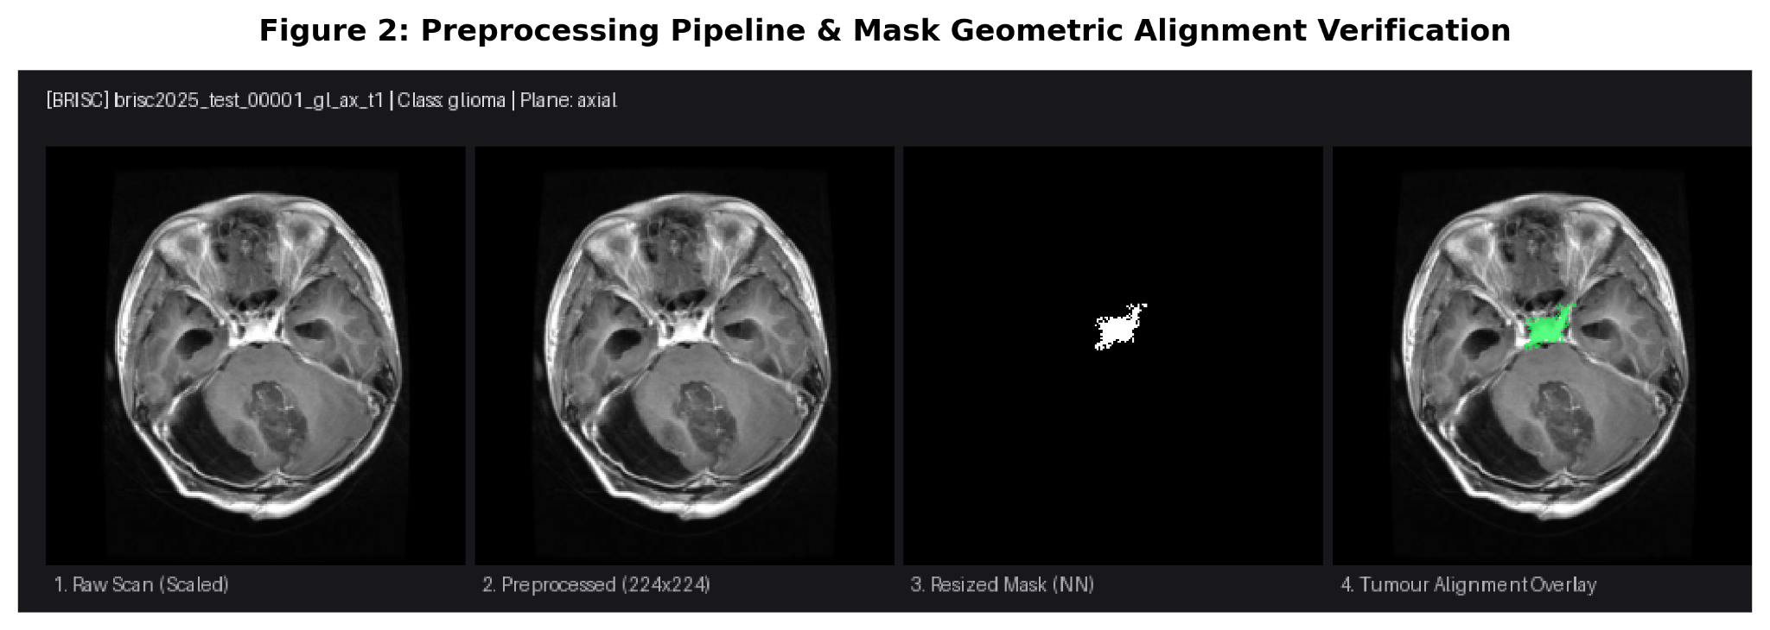
Fig. 2 Preprocessing pipeline and mask geometric alignment verification: raw slice, percentile intensity scaling [P₁, P₉₉], aspect-ratio-preserving letterbox padding (224 × 224) and binary mask boundary alignment.
1. Percentile intensity clamping. Tissue intensities were mapped to [0, 1]:
x̃ = clip((x − P₁(x)) / (P₉₉(x) − P₁(x)), 0, 1) (1)
where P₁ and P₉₉ denote the 1st and 99th percentiles of intracranial tissue.
2. Aspect-ratio-preserving letterbox padding. Slices were scaled along their maximum axis to 224 pixels and symmetrically padded with zeros to 224 × 224. Nearest-neighbour interpolation was enforced for segmentation masks. Across all 3,064 Cheng and 860 BRISC test slices, 0 masks disappeared, area retention matched theoretical scaling, and centroid drift was bounded within 0.0035.
3. Channel standardisation. Slices were replicated to three channels and normalised using ImageNet parameters (μ = [0.485, 0.456, 0.406], σ = [0.229, 0.224, 0.225]). Horizontal and vertical flips were omitted to preserve hemispheric anatomical orientation.
4.2 Model architectures and training protocols
Models were configured in strict concordance with configs/training.yaml.
- ResNet-50 (CNN). 23.51 million parameters; initialised with IMAGENET1K_V2 weights [7]; linear classification head; dropout p = 0.2; initial learning rate 1 × 10⁻⁴.
- DeiT-Small/16 (ViT). 21.66 million parameters; initialised with ImageNet-1k weights [8]; 12 Transformer blocks, 384 embedding dimensions, 6 heads; class-token projection head; dropout p = 0.1; initial learning rate 5 × 10⁻⁵.
- Optimisation. Both architectures were optimised using AdamW with weight decay 1 × 10⁻² and batch size 16. Training ran for up to 5 epochs per fold/split with early stopping (patience of 3 epochs) on validation macro-F1, following a one-epoch linear warm-up and cosine annealing schedule. Standard cross-entropy loss was minimised with random seed 42. The baselines are therefore single-run, short-schedule fine-tuned models, and the Cheng results use Fold 1 only.
- Computational environment. All experiments used Python 3.10.11, PyTorch 2.5.1 and CUDA 12.1 on an NVIDIA RTX 4050 GPU (6 GB VRAM). Hardware, operating system, software versions, git revision and SHA-256 hashes of the model checkpoints are recorded in environment_manifest.json.
4.3 Five-region topological decomposition
For each test slice x with tumour mask M and intracranial tissue support S, five regions were defined:
1. Tumour core (R_{core}). The lesion mask M.
2. Immediate peritumoral margin (R_{immediate}). A 4-pixel dilation ring:
R_{immediate} = (dilate(M, 4) − M) ∩ S (2)
3. Outer peritumoral margin (R_{outer}). A 12-pixel dilation ring:
R_{outer} = (dilate(M, 16) − dilate(M, 4)) ∩ S (3)
4. Remote context (R_{remote}). A tissue patch located more than 32 pixels from the tumour boundary within S.
5. Matched contralateral sham control (R_{sham}). An area- and contour-matched control placed in contralateral normal parenchyma and disjoint from the lesion-centred regions:
R_{sham} ∩ (R_{core} ∪ R_{immediate} ∪ R_{outer}) = ∅ (4)
4.4 Dual counterfactual perturbation engines
- Method A (Telea PDE inpainting). Solves the fast-marching-method boundary problem (cv2.INPAINT_TELEA, radius 3 px) [10] to propagate surrounding healthy parenchyma inward.
- Method B (locally matched Gaussian texture fill). Estimates the local surrounding mean μ_{local} and variance σ_{local}² from a 5-pixel dilated border, and fills the region with Normal(μ_{local}, σ_{local}) smoothed via a 2-pixel cosine border taper. The fill therefore matches the local first- and second-order intensity statistics of the surroundings but not their spatial texture structure, and it is treated as a complementary probe rather than a substitute for inpainting.
- Non-target pixel invariance. Both implementations preserve original pixel values outside the edited mask; the maximum absolute difference was checked in the intervention QC records:
x_{edit}(u, v) = x(u, v) for all (u, v) ∉ R (5)
4.5 Sensitivity estimands and statistical inference
Raw evidence drop (Δ_{r}), sham-corrected region sensitivity (τ_{r}) and top-1 prediction flip (F_{r}) are defined as
Δ_{r}(x) = p_{y}(x) − p_{y}(x_{edit,r}) (6)
τ_{r}(x) = Δ_{r}(x) − Δ_{sham}(x) (7)
F_{r}(x) = 1 if argmax p(x_{edit,r}) ≠ argmax p(x), and 0 otherwise (8)
where p_{y} is the predicted probability of the ground-truth class.
- Hypothesis testing. Two-sided paired Wilcoxon signed-rank tests assess whether region sensitivity differs from the sham control; Holm correction is applied across regions.
- Patient-clustered analysis. For the Cheng cohort, where 45 slices originate from 10 patients, patient-level mean sensitivities were computed and evaluated with clustered Wilcoxon and clustered one-sample t-tests. For the pooled multi-cohort sample (N = 90), clustered inference across 55 independent clusters (10 Cheng patients + 45 BRISC cases) was conducted alongside linear mixed-effects modelling.
- Effect size. Cohen’s d_{z}:
d_{z} = mean(τ_{r}) / SD(τ_{r}) (9)
5 Results
5.1 Baseline classification performance and probability calibration
Baseline models showed moderate-to-good discrimination on both benchmarks, with DeiT-Small clearly stronger than ResNet-50 (Table 1; Fig. 3). Both are short single-run baselines and not tuned to benchmark-level performance. DeiT-Small outperformed ResNet-50 in macro-F1 (Cheng Fold 1, N = 480: 0.8403 vs 0.7190; BRISC clean four-class test, N = 899: 0.8344 vs 0.6991) and in probability calibration. On Cheng Fold 1, DeiT-Small achieved a 10-bin expected calibration error (ECE) [9] of 0.0366, compared with 0.1835 for ResNet-50.
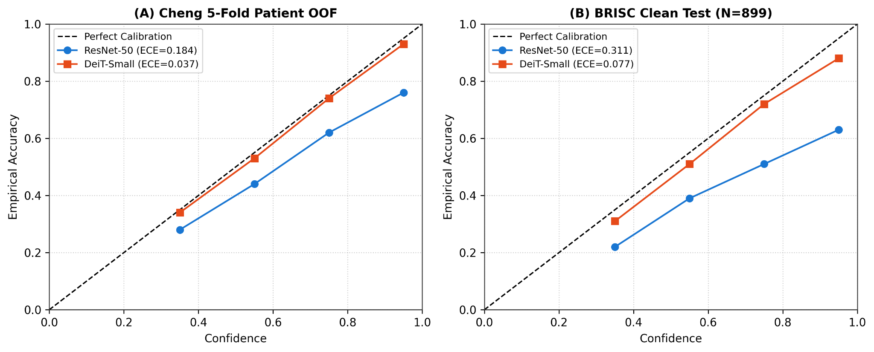
Fig. 3 Reliability diagrams and calibration curves: empirical calibration curves and 10-bin expected calibration error (ECE) for ResNet-50 and DeiT-Small on the Cheng patient-isolated held-out Fold 1 partition and the BRISC clean test set.
Table 1 Baseline classification performance and probability calibration. Panel A: full-label evaluation (Cheng, three classes, Fold 1 held-out partition; BRISC, four classes). Panel B: BRISC mask-supported neoplasm batch, in which only glioma and meningioma are present; macro-F1 is computed over the two present labels.
Dataset | Model | Evaluation partition | Accuracy | Balanced acc. | Macro-F1 | ECE (10-bin) | Brier score
Panel A. Full-label evaluation (Cheng, three classes; BRISC, four classes)
Cheng | ResNet-50 (CNN) | Patient-isolated held-out Fold 1 (N = 480) | 0.7583 | 0.7448 | 0.7190 | 0.1835 | 0.3692
Cheng | DeiT-Small (ViT) | Patient-isolated held-out Fold 1 (N = 480) | 0.8458 | 0.8394 | 0.8403 | 0.0366 | 0.2136
BRISC | ResNet-50 (CNN) | Official test (N = 1,000; full 4-class) | 0.7040 | 0.6870 | 0.7095 | 0.3875 | 0.6510
BRISC | ResNet-50 (CNN) | Clean test (N = 899; de-duplicated) | 0.6963 | 0.6815 | 0.6991 | 0.3790 | 0.6505
BRISC | DeiT-Small (ViT) | Official test (N = 1,000; full 4-class) | 0.7880 | 0.8094 | 0.8030 | 0.0719 | 0.2864
BRISC | DeiT-Small (ViT) | Clean test (N = 899; de-duplicated) | 0.8265 | 0.8330 | 0.8344 | 0.0901 | 0.2448
Panel B. BRISC mask-supported neoplasm batch (two classes present; macro-F1 over present labels)
BRISC | ResNet-50 (CNN) | Official neoplasm batch (N = 480; glioma and meningioma) | 0.6479 | 0.6510 | 0.6919 | 0.3312 | 0.6591
BRISC | ResNet-50 (CNN) | Clean neoplasm batch (N = 397) | 0.6247 | 0.6349 | 0.6574 | 0.3061 | 0.6595
BRISC | DeiT-Small (ViT) | Official neoplasm batch (N = 480; glioma and meningioma) | 0.6875 | 0.6813 | 0.7131 | 0.0421 | 0.3938
BRISC | DeiT-Small (ViT) | Clean neoplasm batch (N = 397) | 0.7456 | 0.7294 | 0.7431 | 0.0718 | 0.3303
Note: For Cheng, evaluations reflect the 480 held-out slices of Fold 1 (49 patients unseen in training), not pooled five-fold out-of-fold predictions. For BRISC, official and clean benchmark scores are computed across the full four-class test partitions (N = 1,000 and N = 899; test_predictions_*_brisc.csv and test_predictions_*_brisc_clean.csv). Panel B reports the mask-supported neoplasm subset (N = 480 official and N = 397 clean; test_predictions_*_neoplasm_480.csv) with the label set fixed to the classes present in each subset.
5.2 Quality control of counterfactual interventions
All 1,200 generated counterfactual interventions met the quality-control gates (Fig. 4):
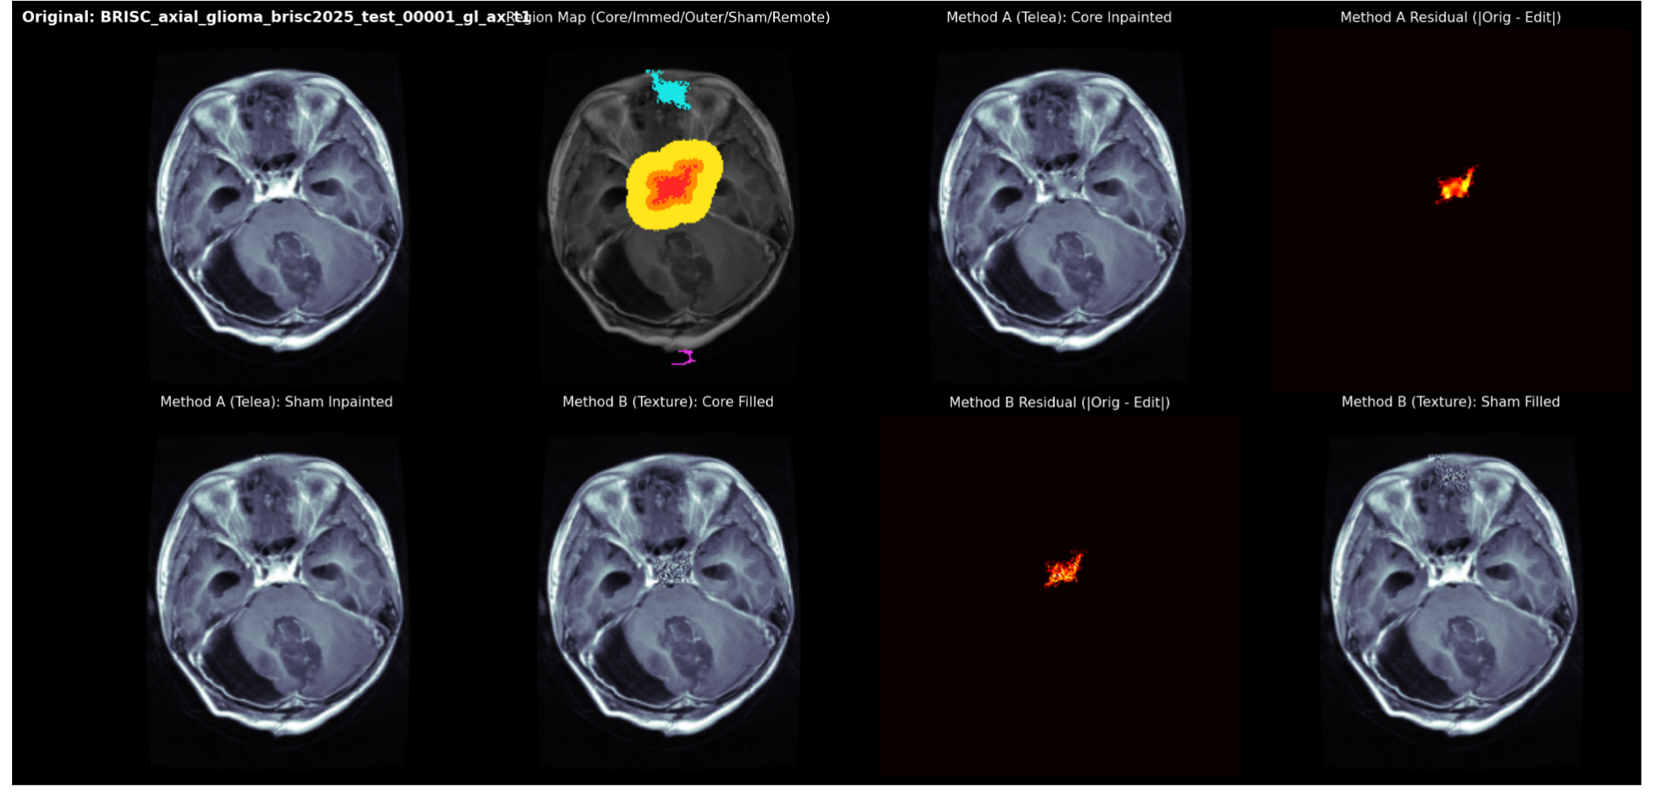
Fig. 4 Counterfactual intervention and residual montage gallery: an eight-panel diagnostic display showing the original slice, the five-colour segmentation topology, Method A inpainted core and sham, Method B texture-filled core and sham, and residual difference maps.
- Non-target preservation. The maximum absolute difference outside the edit mask was 0.00 across all 1,200 edits.
- Intra-mask magnitude. The mean absolute difference (MAD) inside the core mask averaged 0.156–0.232 (Method A) and 0.216–0.259 (Method B).
- Evaluated coverage. All 90 evaluated slices in predictions/intervention_effects.csv have verified QC records in manifests/intervention_qc.csv.
- Edge discontinuity. Boundary gradient offsets were bounded (0.16–0.24); this measure does not imply that the edited regions are artefact-free.
5.3 Primary counterfactual sensitivity: core versus margin evidence
Evaluation of the 1,800 paired counterfactual observations in predictions/intervention_effects.csv revealed spatial sensitivities that differ across architectures and intervention methods (Table 2; Fig. 5).
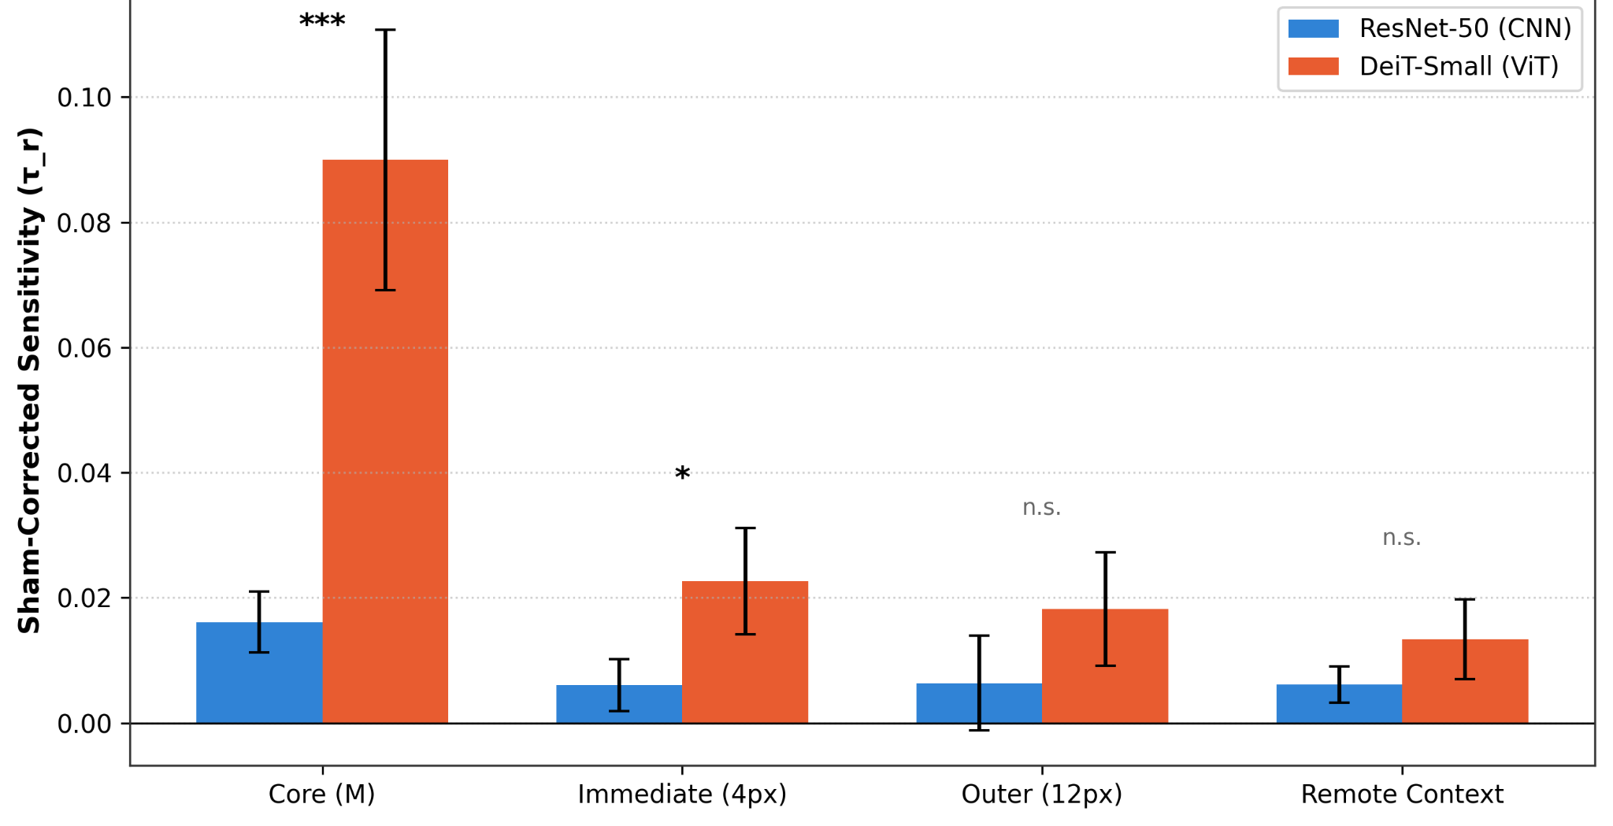
Fig. 5 Regional evidence sensitivity across architectures (Method A, inpainting), pooled across the Cheng and BRISC intervention subsets (N = 90 slices): sham-corrected sensitivity (τ_{r}) for the tumour core, immediate margin (4 px), outer margin (12 px) and remote context. Error bars show the standard error of the mean; asterisks mark paired Wilcoxon significance against sham (* p < 0.05, *** p < 0.001; n.s., not significant).
Table 2 Regional evidence sensitivity and hypothesis testing. Shown are 12 of the 40 dataset × model × method × region estimates: all four regions for DeiT-Small with Method A in each cohort, plus core sensitivity (and the immediate margin for ResNet-50 Method A) for the remaining Cheng model–method combinations. Values for Δ_{r} and τ_{r} are mean ± SD. Holm adjustment is applied across the four regions within each dataset–model–method set.
Dataset | Model | Method | Region | Raw sensitivity (Δ_{r}) | Sham-corrected (τ_{r}) | Flip rate | Raw Wilcoxon p | Holm-adj. p | Cohen’s d_{z}
Cheng (N = 45) | DeiT-Small | A (Telea) | Core | 0.1212 ± 0.245 | 0.1282 ± 0.245 | 13.3% | 9.13×10⁻⁶ | 3.65×10⁻⁵ | 0.518
Cheng (N = 45) | DeiT-Small | B (Texture) | Core | 0.1577 ± 0.241 | 0.1449 ± 0.214 | 8.9% | 3.09×10⁻⁸ | 1.24×10⁻⁷ | 0.669
Cheng (N = 45) | DeiT-Small | A (Telea) | Immediate (4 px) | 0.0143 ± 0.082 | 0.0213 ± 0.096 | 8.9% | 0.0267 | 0.0802 | 0.222
Cheng (N = 45) | DeiT-Small | A (Telea) | Outer (12 px) | −0.0007 ± 0.091 | 0.0063 ± 0.098 | 8.9% | 0.2866 | 0.2866 | 0.064 (n.s.)
Cheng (N = 45) | DeiT-Small | A (Telea) | Remote context | 0.0058 ± 0.030 | 0.0128 ± 0.065 | 2.2% | 0.0801 | 0.1603 | 0.196 (n.s.)
Cheng (N = 45) | ResNet-50 | A (Telea) | Core | 0.0264 ± 0.041 | 0.0311 ± 0.056 | 8.9% | 6.54×10⁻⁴ | 2.60×10⁻³ | 0.548
Cheng (N = 45) | ResNet-50 | B (Texture) | Core | 0.0844 ± 0.134 | 0.0603 ± 0.150 | 31.1% | 0.0173 | 0.0691 | 0.396
Cheng (N = 45) | ResNet-50 | A (Telea) | Immediate (4 px) | 0.0079 ± 0.036 | 0.0125 ± 0.050 | 6.7% | 0.0621 | 0.1242 | 0.248
BRISC (N = 45) | DeiT-Small | A (Telea) | Core | 0.0367 ± 0.096 | 0.0517 ± 0.147 | 8.9% | 1.85×10⁻⁶ | 7.40×10⁻⁶ | 0.352
BRISC (N = 45) | DeiT-Small | A (Telea) | Immediate (4 px) | 0.0089 ± 0.048 | 0.0239 ± 0.093 | 6.7% | 0.0094 | 0.0188 | 0.257
BRISC (N = 45) | DeiT-Small | A (Telea) | Outer (12 px) | 0.0150 ± 0.065 | 0.0301 ± 0.070 | 11.1% | 0.0049 | 0.0147 | 0.425
BRISC (N = 45) | DeiT-Small | A (Telea) | Remote context | −0.0010 ± 0.018 | 0.0140 ± 0.056 | 6.7% | 0.2815 | 0.2815 | 0.249 (n.s.)
Note: Holm-adj.: Holm-adjusted; n.s.: not significant.
Non-monotonic spatial dynamics and patient-clustered analysis.
- Core evidence dominance versus method dependency. Core dominance is strongly evident in Vision Transformers under PDE inpainting on Cheng, where core sensitivity (τ_{core} = 0.1282) far exceeds margin effects (τ_{immediate} = 0.0213, τ_{outer} = 0.0063, τ_{remote} = 0.0128). However, spatial decay is not universally monotonic: under Method B (locally matched Gaussian texture fill) and in skull-stripped BRISC scans, outer-margin effects frequently equal or approach core sensitivity (e.g. BRISC DeiT outer τ = 0.0301 vs core τ = 0.0517). The outer ring covers more tissue than the immediate ring and may include perilesional signal and boundary texture. The experiment does not isolate oedema as the cause of measured sensitivity.
- Patient-clustered statistical inference. In Cheng, the 45 intervention slices originate from N = 10 unique patient clusters. While slice-level Wilcoxon tests yield p = 9.13 × 10⁻⁶ for DeiT-Small and p = 6.54 × 10⁻⁴ for ResNet-50, the patient-clustered Wilcoxon signed-rank test across the 10 patient-mean core sensitivities of DeiT-Small gave W = 53.0, p = 0.0059. Patient clustering shows that the effective sample size is N = 10, so slice-level p-values overstate precision; with ten clusters the clustered result is supportive but limited evidence that core sensitivity exceeds sham.
- Remote context invariance. Remote-region effects were non-significant in the highlighted comparisons (BRISC DeiT Telea p = 0.2815; Cheng DeiT Telea p = 0.0801 before multiplicity correction). Under Method B, which fills the region with noise matched to the local mean and variance of its surroundings, DeiT-Small remote sensitivity was likewise low and non-significant (τ_{remote} = 0.0052, p = 0.4571), whereas ResNet-50 showed higher remote-parenchyma sensitivity under the same perturbation. Non-significance is not proof of zero effect or of complete shortcut independence.
- Region area and per-pixel sensitivity. Regions differ in size and only the sham is area-matched to the core, so differences between regions may partly reflect area. The outer margin was on average 2.2 times larger than the tumour core (mean 2,239 vs 1,013 px). Normalised per 1,000 edited pixels, sensitivity ranged from 0.049 to 0.136 for the core and from 0.015 to 0.036 for margin and remote regions, so evidence density was higher in the core in the summarised comparisons.
5.4 Architectural inductive bias: ViT versus CNN
Paired comparison between DeiT-Small and ResNet-50 showed architectural divergences (Fig. 6).
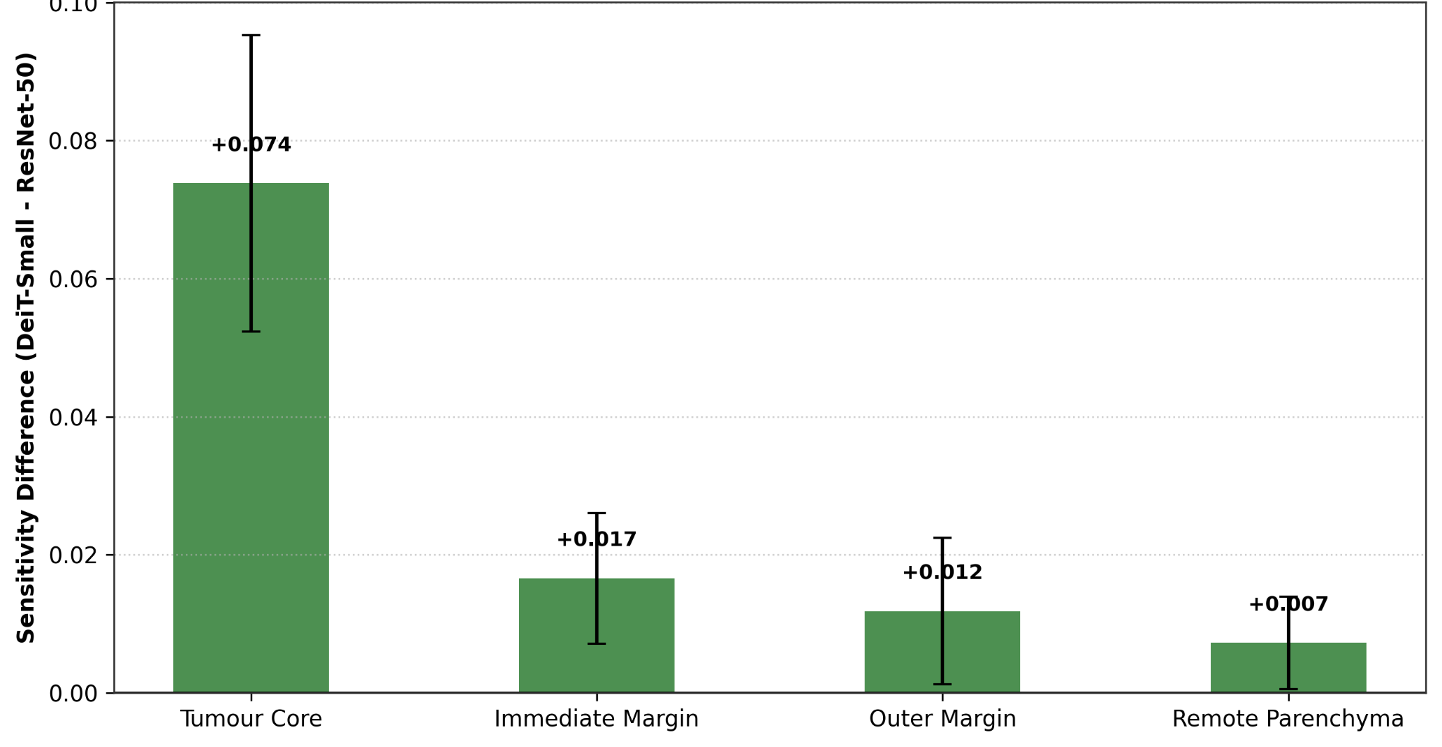
Fig. 6 Architectural inductive bias, ViT versus CNN regional sensitivity profile (Method A): difference plot (τ_{ViT} − τ_{CNN}) highlighting the greater reliance of DeiT-Small on intra-lesion core and transitional margin evidence.
- Intra-lesion core reliance. In the pooled multi-cohort comparison (N = 90, Method A), DeiT-Small showed higher mean sensitivity to core ablations than ResNet-50 (τ_{core,ViT} = 0.0900 vs τ_{core,CNN} = 0.0161; difference +0.0738; slice-level paired Wilcoxon p = 0.0123, Holm-adjusted p = 0.0980; Cohen’s d_{z} = 0.362). Treated as hypotheses rather than established effects, these pooled results should be read together with the Cheng-only result below. Under cluster-level inference across 55 clusters (10 Cheng patient clusters + 45 BRISC sample clusters), the pooled difference was supported by a cluster-level Wilcoxon p = 0.0162, a cluster-level t-test p = 0.00177, and a linear mixed-effects fixed effect β_{ViT} = +0.074 (z = 3.756, p < 0.001). In the Cheng-specific subset (N = 45), the core sensitivity difference was 0.1282 − 0.0311 = +0.0971 (slice-level Wilcoxon p = 0.156; patient-clustered Wilcoxon p = 0.232; clustered t-test p = 0.148). The result is pooled-cohort evidence and should not be read as a Cheng-only effect; the Cheng-specific comparison was not significant.
- Transitional margin reliance. DeiT-Small displayed moderately higher sensitivity to the immediate peritumoral margin across the pooled cohort (τ = 0.0270 vs 0.0104; difference +0.0166; p = 0.1124) and to the outer margin (difference +0.0118).
- Remote-region comparison. The pooled difference between architectures for remote-region sensitivity was small (difference +0.0072; p = 0.9087). This audit did not show a detectable architectural difference; it does not prove that either model is free of background shortcuts.
5.5 Perturbation method concordance
The two perturbation engines did not produce uniformly concordant effects (Fig. 7). The correlation between Telea and texture-fill core sensitivities was r = 0.748 (Spearman ρ = 0.541) when pooled across models on Cheng, and r = 0.300 (ρ = 0.332) on BRISC. Across the region-by-dataset comparisons, correlations varied substantially, including weak or near-zero associations for several margin and remote regions. This indicates that measured sensitivity is partly intervention-dependent. Texture filling should therefore be interpreted as a complementary perturbation, not as an interchangeable substitute for inpainting. The results do not establish that one architecture is intrinsically more sensitive to a particular artefact mechanism.
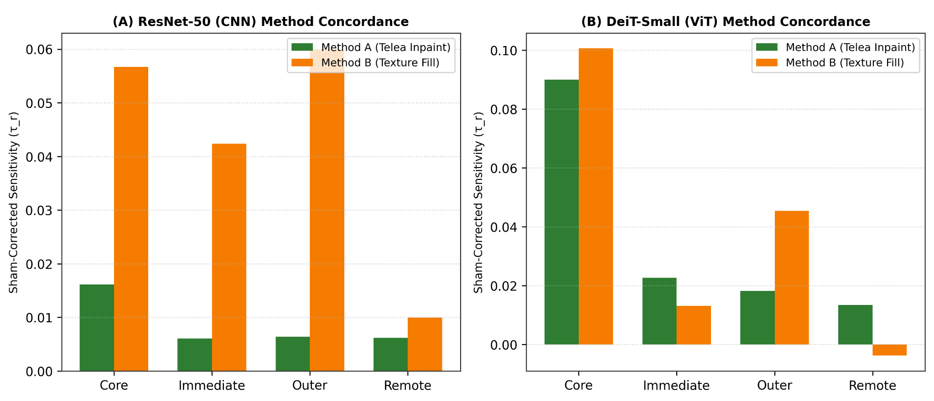
Fig. 7 Perturbation method concordance, Telea inpainting versus matched texture fill: paired sensitivity comparison between Telea boundary inpainting and locally matched Gaussian texture filling across ResNet-50 and DeiT-Small.
5.6 Imaging plane stratification (BRISC)
Stratifying BRISC by acquisition plane (Table 3; Fig. 8) showed positive core sensitivity in all three planes: axial τ_{core} = 0.0492, coronal 0.0370 and sagittal 0.0690 (N = 15 slices each). The plane-stratified mean (0.0517) equals the BRISC DeiT-Small Method A core entry in Table 2. This is a descriptive split of 15 slices per plane.
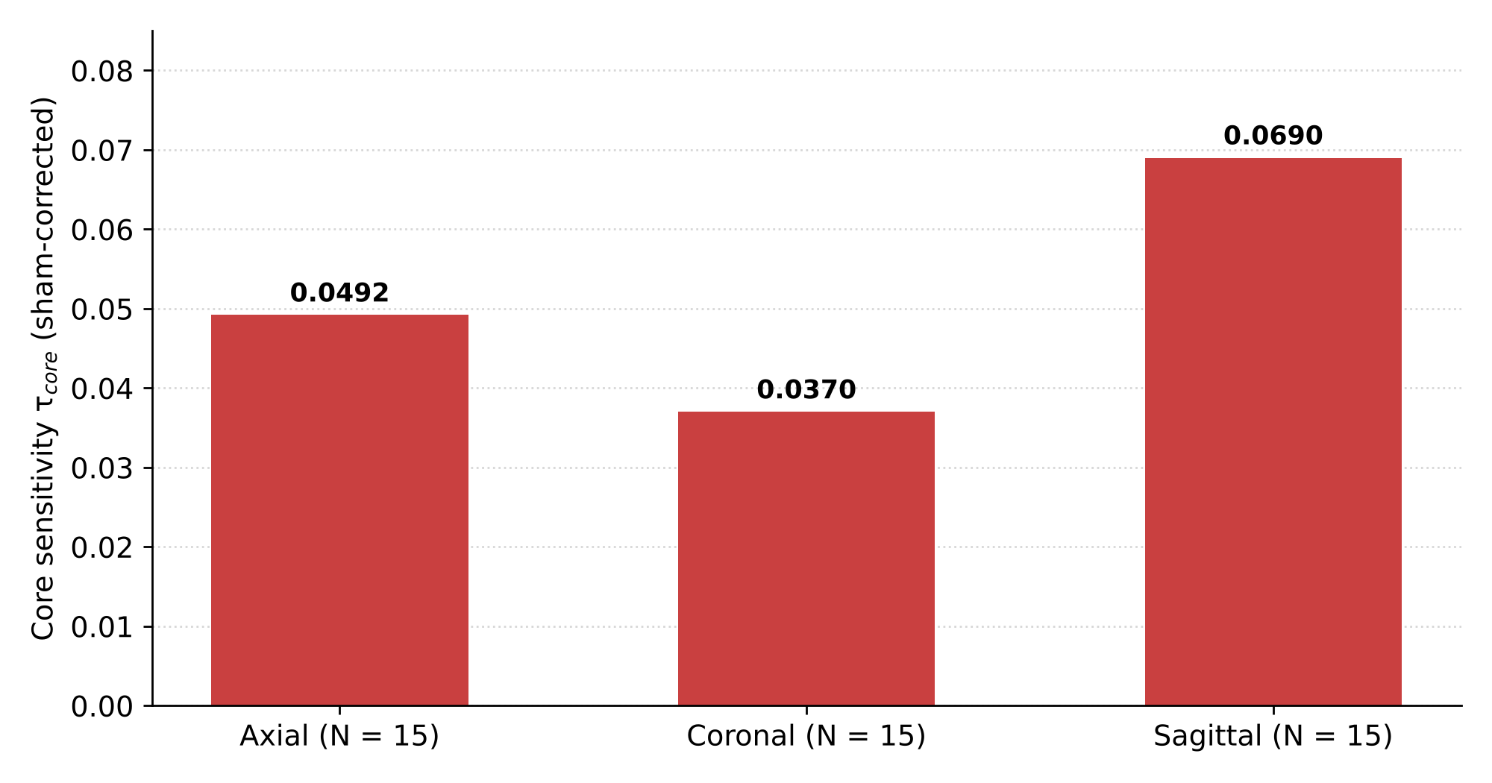
Fig. 8 Core sensitivity by acquisition plane (BRISC, DeiT-Small, Method A): axial (N = 15), coronal (N = 15) and sagittal (N = 15).
Table 3 Core sensitivity by acquisition plane (BRISC, DeiT-Small, Method A).
Acquisition plane | Sample count (N) | Mean core τ_{core}
Axial | 15 | 0.0492
Coronal | 15 | 0.0370
Sagittal | 15 | 0.0690
Note: Descriptive sample; no inferential test of plane differences is claimed. The mean of the three plane values (0.0517) matches Table 2.
5.7 Exploratory tumour class heterogeneity
Core sensitivity differed markedly across Cheng tumour classes (Table 4; Fig. 9): meningioma 0.3438, glioma 0.0398 and pituitary adenoma 0.0009 (N = 15 slices each). The mean of the three class values (0.1282) equals the Cheng DeiT-Small Method A core entry in Table 2, so the cohort-level core sensitivity is driven largely by the meningioma subset.
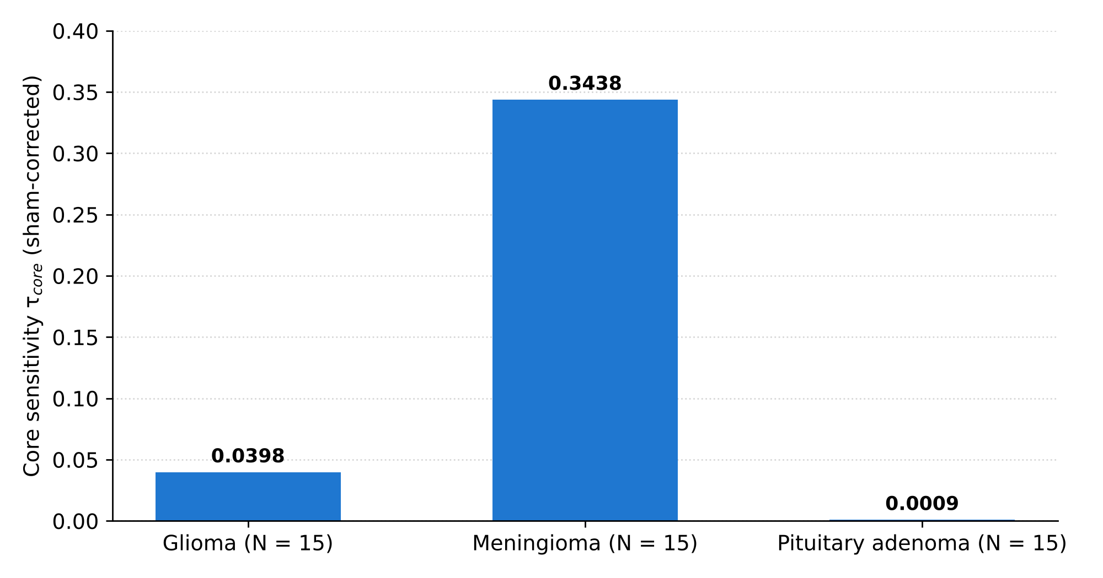
Fig. 9 Core sensitivity by tumour class (Cheng, DeiT-Small, Method A): glioma, meningioma and pituitary adenoma (N = 15 each).
- Gliomas. Low core sensitivity (τ_{core} = 0.0398).
- Meningiomas. The highest core sensitivity (τ_{core} = 0.3438).
- Pituitary adenomas. Near-zero core sensitivity (τ_{core} = 0.0009).
Table 4 Core sensitivity by tumour class (Cheng, DeiT-Small, Method A).
Tumour class | Sample count (N) | Core sensitivity (τ_{core})
Glioma | 15 | 0.0398
Meningioma | 15 | 0.3438
Pituitary adenoma | 15 | 0.0009
Note: Exploratory and descriptive; 15 slices per class from the 10 Cheng patient clusters, with no inferential test and no histopathological correlation. No radiological explanation for the class differences is tested here.
5.8 Impact of benchmark duplicate leakage
Comparing performance between the official benchmark (N = 1,000) and the de-duplicated clean test set (N = 899) showed that removing the 101 duplicate test images changed the measured performance in a model-dependent direction (Table 1; Fig. 10). On the four-class test set, DeiT-Small improved from 0.7880 to 0.8265 accuracy (+0.038) and from 0.8030 to 0.8344 macro-F1 (+0.031), whereas ResNet-50 changed little (accuracy 0.7040 to 0.6963; macro-F1 0.7095 to 0.6991). In the two-class neoplasm batch, with macro-F1 computed over the two present labels, DeiT-Small changed from 0.7131 to 0.7431 and ResNet-50 from 0.6919 to 0.6574. The 101 duplicate test images were heavily skewed towards meningiomas (96 of 101), so de-duplication also changed the test-set class balance. The data therefore do not support a uniform inflation of scores by duplicate leakage; the effect depends on the model and on the class composition of the subset.
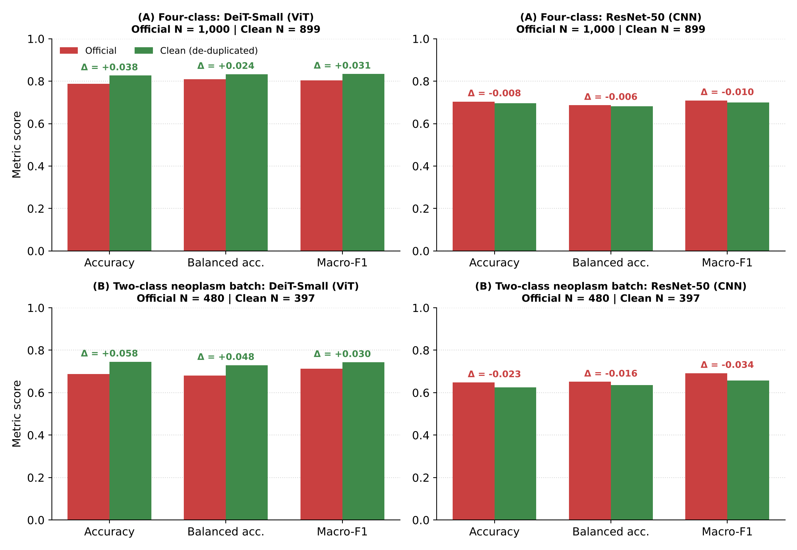
Fig. 10 Impact of train–test duplicate leakage on benchmark evaluation (BRISC): official test set versus clean de-duplicated test set for DeiT-Small and ResNet-50. (A) Four-class evaluation (N = 1,000 vs 899). (B) Two-class neoplasm batch (N = 480 vs 397). Δ is clean minus official; axes start at zero.
5.9 Evaluation of the study hypotheses
- Hypothesis 1 (spatial evidence gradient): partially supported. Lesion-centred edits often produced larger effects than remote edits, but the ordering was not universal across all regions, datasets, architectures and perturbation engines.
- Hypothesis 2 (margin contribution): partially supported. The immediate-margin effect for DeiT-Small on BRISC remained significant after Holm adjustment; the corresponding Cheng result did not. Evidence therefore depends on cohort and multiplicity correction.
- Hypothesis 3 (ViT inductive bias): partially supported; inconclusive for the Cheng-only comparison. The pooled cluster-level comparison favoured DeiT-Small, but the slice-level Holm-adjusted p-value was 0.0980 and the Cheng-only architectural comparison was not significant in the patient-clustered analysis. DeiT-Small also had lower ECE on the reported baseline partitions, but baseline confidence and calibration differ between the models, which may influence probability-drop estimates.
- Hypothesis 4 (perturbation method concordance): not uniformly supported. Cross-method correlations were variable and weak for several regions; the two edit engines should be treated as complementary probes.
- Hypothesis 5 (leakage and prior distortion): archive-specific finding, partly supported. Exact duplicate matches were detected in the evaluated BRISC archive and changed the measured metrics in a model-dependent direction, but the result should not be generalised to every BRISC distribution or mirror.
6 Discussion
6.1 Principal findings
Our sham-controlled audit provides evidence that tumour-core perturbations reduce ground-truth-class probabilities in several model/cohort settings and that selected peritumoral edits can also affect predictions. Sham correction helps separate lesion-region effects from the response to an anatomically separate control edit. The study is a mechanistic audit of spatial reliance, not a test of diagnostic deployability. The results are conditional on the perturbation operator and the evaluated subsets; non-significant remote-region tests do not establish the absence of all shortcut learning or scanner-related confounding.
6.2 Lesion core versus peritumoral margin evidence
The observed immediate-margin effects were modest and varied by cohort and method. For DeiT-Small under Telea inpainting, the mean sham-corrected immediate-margin sensitivity was 0.0213 on Cheng (raw p = 0.0267; Holm-adjusted p = 0.0802) and 0.0239 on BRISC (raw p = 0.0094; Holm-adjusted p = 0.0188). These findings are compatible with models using some information in tissue adjacent to the lesion, but do not by themselves identify the underlying radiological substrate or demonstrate histopathological infiltration.
6.3 Architectural inductive bias: attention versus convolution
The results are compatible with, but do not test, the following hypotheses about how architectural inductive biases may shape diagnostic representations:
- Possible receptive-field effect. ResNet-50 showed lower sensitivity to core perturbations (τ ≈ 0.031 on Cheng, Method A) and greater sensitivity to edge artefacts under texture filling. Receptive-field constraints are one possible explanation, but this is untested: Δ is a drop in probability and depends on baseline confidence and calibration, which differ substantially between the models (ECE 0.04–0.09 for DeiT-Small vs 0.18–0.39 for ResNet-50).
- Possible global-context effect. DeiT-Small showed higher core sensitivity (τ ≈ 0.052–0.128) and lower ECE (0.037 vs 0.184 on Cheng), with no detectable remote-context sensitivity under Method A (τ_{remote} ≈ 0.013, p > 0.05). Self-attention integration of spatial context is a hypothesis that these single-run baselines cannot confirm.
6.4 Benchmark leakage, provenance and data governance
The identical-pixel duplicate matches spanning the official train–test boundary in the evaluated BRISC archive highlight the need for data-governance checks. De-duplication changed the measured metrics in a model-dependent direction and altered the class composition of the test set (96 of 101 duplicated test images were meningiomas). We recommend transparent decoded-pixel and perceptual-hash audits, together with patient- or case-grouped splitting when reliable identifiers are available.
6.5 Limitations
Several limitations must be acknowledged:
- 2D slices versus volumetric 3D MRI. Our analysis evaluated 2D contrast-enhanced slices. Neuroradiologists assess multi-sequence 3D volumes (T1, T1+C, T2, FLAIR) in clinical practice.
- Synthetic perturbations. The intervention code preserves pixels outside the target mask, and the repository reports zero measured non-target difference in its QC export. Nevertheless, Telea inpainting and Gaussian texture replacement create synthetic counterfactuals that may be out of distribution and do not simulate true healthy tissue, tumour resection or biological disease progression.
- Patient/case cluster sample size. The Cheng intervention subset (45 slices) represents only 10 patients, and the BRISC audit subset represents 45 slice-level cases. Cluster-level inference is more conservative than treating all slices as independent, but the number of independent clusters remains limited, and case-level independence in BRISC follows the available sample identifiers rather than confirmed patient identities.
- Exploratory class inferences. Class-specific analyses use 15 slices per tumour class in the Cheng intervention subset and 2D image masks/labels; they are descriptive and are not linked to independently reviewed histopathology or volumetric tumour boundaries.
- Single-run baselines. Both models were fine-tuned for at most five epochs with one seed, and the Cheng analyses use Fold 1 only. The baselines (e.g. ResNet-50 accuracy 0.70 on BRISC four-class) are weaker than published benchmark results, so the audited models are not state-of-the-art classifiers and the architectural comparisons may not carry over to converged models.
- Region area and perturbation realism. Only the sham is area-matched to the core, and Method B matches local intensity statistics but not spatial texture; per-pixel sensitivities are reported for context, not as a corrected estimate.
7 Conclusion
This study presents a sham-controlled, mechanistic counterfactual audit of ResNet-50 and DeiT-Small on two contrast-enhanced brain MRI cohorts. Lesion-core perturbations produced measurable reductions in predicted probability in several settings; immediate and outer-margin effects were more variable, and remote-region effects were generally smaller in the highlighted comparisons. DeiT-Small achieved higher baseline performance and lower ECE on the reported partitions, while its pooled core-sensitivity advantage requires qualified interpretation because slice-level Holm adjustment and clustered analyses answer different inferential questions. The archive-specific duplicate audit illustrates why benchmark provenance, patient/case grouping, intervention quality control and transparent sample accounting should accompany performance metrics. The study makes no claim of diagnostic deployability; external multi-centre and volumetric validation, and converged multi-seed baselines, remain necessary before any clinical use.
Statements and Declarations
Funding. This research did not receive any specific grant from funding agencies in the public, commercial or not-for-profit sectors.
Competing interests. The authors declare that they have no competing financial or non-financial interests that could have appeared to influence the work reported in this paper.
Ethics approval and consent to participate. This study analysed publicly available, de-identified retrospective MRI datasets; no new data were collected and no participants were recruited. Institutional ethics determination or exemption reference: [to be inserted by the authors].
Consent for publication. Not applicable.
Data availability. The Cheng dataset is publicly accessible at Figshare (doi:10.6084/m9.figshare.1512427). The BRISC dataset is available through the dataset distribution described by Fateh et al. (doi:10.1038/s41597-026-06753-y). Audited manifests, split files, de-duplication mappings and prediction files are provided in the project repository; raw datasets are not redistributed, and SHA-256 hashes of the model checkpoints are recorded in environment_manifest.json.
Code availability. Source code, preprocessing scripts, model architectures, counterfactual intervention engines, evaluation scripts (including compute_all_tables.py and generate_revised_figures.py), the source-to-result mapping (source_to_result_mapping.csv) and the Pytest validation suite (41 tests) are hosted in the project repository: [repository URL / DOI to be inserted by the authors].
Use of generative AI. Generative AI assistants were used for code development and checking, consistency checks of tables and figures, and language editing of the manuscript. The authors reviewed and verified all outputs and take full responsibility for the content of the paper.
Author contributions. Chhotu: conceptualisation, methodology, counterfactual intervention engine design, data preprocessing and de-duplication audits, statistical analysis, visualisation, writing – original draft. Rishi Gupta: supervision, investigation, biostatistical review, validation, research integrity auditing, writing – review and editing.
References
[1] Wallis, D., Buvat, I.: Clever Hans effect found in a widely used brain tumour MRI dataset. Med. Image Anal. 77, 102368 (2022) https://doi.org/10.1016/j.media.2022.102368
[2] Cheng, J., Huang, W., Cao, S., et al.: Enhanced performance of brain tumor classification via tumor region augmentation and partition. PLOS ONE 10(10), e0140381 (2015) https://doi.org/10.1371/journal.pone.0140381
[3] Rossi, E.B., Lopez, E., Comminiello, D.: TACE: Tumor-aware counterfactual explanations for medical image analysis. arXiv preprint arXiv:2409.13045 (2024) https://doi.org/10.48550/arXiv.2409.13045
[4] Sourget, T., Hestbek-Møller, M., Jiménez-Sánchez, A., Xu, J.J., Cheplygina, V.: Mask of truth: model sensitivity to unexpected regions of medical images. J. Imaging Inform. Med. (2025) https://doi.org/10.1007/s10278-025-01531-5
[5] Fateh, A., et al.: BRISC: annotated dataset for brain tumor segmentation and classification. Sci. Data 13, 361 (2026) https://doi.org/10.1038/s41597-026-06753-y
[6] Yagis, E., et al.: Effect of data leakage in brain MRI classification using 2D convolutional neural networks. Sci. Rep. 11(1), 22544 (2021) https://doi.org/10.1038/s41598-021-01681-w
[7] He, K., Zhang, X., Ren, S., Sun, J.: Deep residual learning for image recognition. In: Proc. IEEE Conf. Computer Vision and Pattern Recognition (CVPR), pp. 770–778 (2016) https://doi.org/10.1109/CVPR.2016.90
[8] Touvron, H., Cord, M., Douze, M., et al.: Training data-efficient image transformers & distillation through attention. In: Proc. Int. Conf. Machine Learning (ICML), pp. 10347–10357 (2021)
[9] Guo, C., Pleiss, G., Sun, Y., Weinberger, K.Q.: On calibration of modern neural networks. In: Proc. Int. Conf. Machine Learning (ICML), pp. 1321–1330 (2017)
[10] Telea, A.: An image inpainting technique based on the fast marching method. J. Graph. Tools 9(1), 23–34 (2004) https://doi.org/10.1080/10867651.2004.10487596
[11] Geirhos, R., et al.: Shortcut learning in deep neural networks. Nat. Mach. Intell. 2(11), 665–673 (2020) https://doi.org/10.1038/s42256-020-00257-z
[12] Goyal, Y., Wu, Z., Ernst, J., Batra, D., Parikh, D., Lee, S.: Counterfactual visual explanations. In: Proc. 36th Int. Conf. Machine Learning (ICML), PMLR 97, pp. 2376–2384 (2019)
[13] Rudin, C.: Stop explaining black box machine learning models for high stakes decisions and use interpretable models instead. Nat. Mach. Intell. 1(5), 206–215 (2019) https://doi.org/10.1038/s42256-019-0048-x
[14] DeGrave, A.J., Janizek, J.D., Lee, S.-I.: AI for radiographic COVID-19 detection frequently relies on spurious shortcuts. Nat. Mach. Intell. 3(7), 610–619 (2021) https://doi.org/10.1038/s42256-021-00338-7

